Regulatory Committee
Meeting to be held on Wednesday, 6 June 2018

Electoral Division affected:
Lancaster Central;

Wildlife and Countryside Act 1981
Definitive Map Modification Order Investigation
Application for recording on the Definitive Map and Statement a Restricted Byway along Aldcliffe Hall Drive, Lancaster
File No. 804-592
(Annex ‘A’ refers)

Contact for further information:
Claire Blundell, 01772 533196, Paralegal Officer, County Secretary and Solicitors Group, Claire.blundell@lancashire.gov.uk
Jayne Elliott, 01772 537663, Public Rights of Way Definitive Map Officer, Planning and Environment Group, jayne.elliott@lancashire.gov.uk

Executive Summary

Application for the addition to the Definitive Map and Statement of Public Rights of Way, of a restricted byway along Aldcliffe Hall Drive, Aldcliffe with Stodday, in accordance with File No. 804-592.

Recommendation

- That the application for a restricted byway along the route known as Aldcliffe

Hall Drive, in accordance with File No. 804-592, be accepted in part.

- That an Order be made pursuant to Section 53 (2)(b) and Section 53 (3)(b)

and Section 53 (3)(c)(i) the Wildlife and Countryside Act 1981 to add to the Definitive Map and Statement of Public Rights of Way a bridleway as shown on Committee Plan between points A-B-C-D.

- That being satisfied that the higher test for confirmation can be met the Order

be promoted to confirmation.

Background

An application under Schedule 14 of the Wildlife and Countryside Act 1981 has been received for a Restricted Byway to be recorded on the Definitive Map and Statement of Public Rights of Way, along the route known as Aldcliffe Hall Drive from Aldcliffe Road to Aldcliffe Hall Lane in the Parish of Aldcliffe with Stodday, Lancaster City as shown between points A-B-C-D on the Committee plan.

The county council is required by law to investigate the evidence and make a decision based on that evidence as to whether a public right of way exists, and if so its status. Section 53(3)(b) and (c) of the Wildlife and Countryside Act 1981 set out the tests that need to be met when reaching a decision; also current Case Law needs to be applied.

An order will only be made to add a public right of way to the Definitive Map and Statement if the evidence shows that:

- A right of way “subsists” or is “reasonably alleged to subsist”

An order for adding a way to or upgrading a way shown on the Definitive Map and Statement will be made if the evidence shows that:

- “the expiration… of any period such that the enjoyment by the public…raises a presumption that the way has been dedicated as a public path or restricted byway”

When considering evidence, if it is shown that a highway existed then highway rights continue to exist (“once a highway, always a highway”) even if a route has since become disused or obstructed unless a legal order stopping up or diverting the rights has been made. Section 53 of the Wildlife and Countryside Act 1981 (as explained in Planning Inspectorate’s Advice Note No. 7) makes it clear that considerations such as suitability, the security of properties and the wishes of adjacent landowners cannot be considered. The Planning Inspectorate’s website also gives guidance about the interpretation of evidence.

The county council’s decision will be based on the interpretation of the evidence discovered by officers and documents and other evidence supplied by the applicant, landowners, consultees and other interested parties produced to the county council before the date of the decision. Each piece of evidence will be tested and the evidence overall weighed on the balance of probabilities. It is possible that the council’s decision may be different from the status given in any original application. The decision may be that the routes have public rights as a footpath, bridleway, restricted byway or byway open to all traffic, or that no such right of way exists. The decision may also be that the routes to be added or deleted vary in length or location from those that were originally considered.

Consultations

Lancaster City Council

The Lancaster City Borough Council responded to consultations and provided that they do not have any interest in the area in question.

Aldcliffe with Stodday Parish Council

The parish council submitted and support the application.

Applicant/Landowners/Supporters/Objectors

The evidence submitted by the applicant/landowners/supporters/objectors and observations on those comments are included in Advice – Head of Service – Legal and Democratic Services Observations section.

Advice

Head of Service – Planning and Environment

Points annotated on the attached Committee plan.

Point | Grid Reference (SD) | Description
A | 4694 6041 | Junction with Aldcliffe Road
B | 4681 6030 | Field gates adjacent to either side of the route
C | 4673 6028 | Posts in surface of application route
D | 4660 6016 | Junction with Aldcliffe Hall Lane

Description of Route

A site inspection was carried out on 10th March 2018.

The application route is approximately 430 metres long. It starts at a point on Aldcliffe Road (point A) adjacent to the Lancaster canal and passes immediately between two large stone gateposts adjacent to East Lodge (a Grade 2 listed building) and along the tarmac driveway and within a fenced off grass strip of land lined with trees and with grazing fields beyond.

The route ascends gently uphill following the tarmac driveway to point B, where field gates are located on either side of the route, which open across the route to allow animals to pass between the fields on either side of the driveway.

Beyond point B, the route continues along the tarmac drive passing the entrances to Ashlar House and Ashlar Lodge on the right (north) to point C where concrete posts have been erected in the surface of the route which prevent vehicular access (although motorbikes and quad bikes could get through). To the south of the route a housing estate is being constructed which is accessed from Aldcliffe Road although access is also available to some of the newly built houses from the application route between points C-D.

Google Street View images taken in 2015 (and included later in the report) show the bollards at point C extending across the tarmac driveway and adjacent grass verge in 2015 whereas in 2018, due to the new housing development, the tarmac driveway and bollards appear unaltered, but the adjacent grass verge no longer exists.

West of point C, the application route continues as a tarmac road providing access to properties on either side. The last 95 metres of the route (from the property known as Rydal Mount to point D) separate footways also exist on either side of the tarmac road.

At point D, the application route meets Aldcliffe Hall Lane where a street sign is located naming the application route as 'Aldcliffe Hall Drive'.

Map and Documentary Evidence

The application route crosses land which formed part of the Aldcliffe Hall Estate in the 1800s through to the 1950s.

Online research (Wikipedia) about the history of Aldcliffe Hall revealed that the Hall was built by Edward Dawson in 1817 and replaced an older medieval hall which existed on a slightly different site and which originally formed part of the Dalton Estate.

By 1827, Edward Dawson is said to have added a drive, a lodge and a tree lined carriageway.

In 1946, the contents of the Hall were sold and in 1950 the Hall became a hostel for displaced foreign workers until it was sold by the Dawson family in 1953. The Hall was demolished in 1960 and the land subsequently sold for housing.

Document Title | Date | Brief Description of Document & Nature of Evidence
Yates’ Map  of Lancashire | 1786 | Small scale commercial map. Such maps were on sale to the public and hence to be of use to their customers the routes shown had to be available for the public to use. However, they were privately produced without a known system of consultation or checking. Limitations of scale also limited the routes that could be shown.
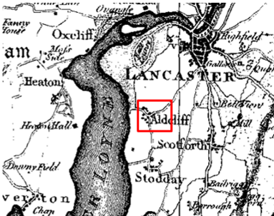
Observations |  | The village of Aldcliffe is shown with the existing public vehicular network of Aldcliffe Road, Stodday Lane and Aldcliffe Hall Lane but the application route is not shown.
Investigating Officer's Comments |  | It is likely that the route, if it existed in 1786, was of little significance and was therefore not included on the map.
Greenwood’s Map of Lancashire | 1818 | Small scale commercial map. In contrast to other map makers of the era Greenwood stated in the legend that this map showed private as well as public roads and the two were not differentiated between within the key panel.
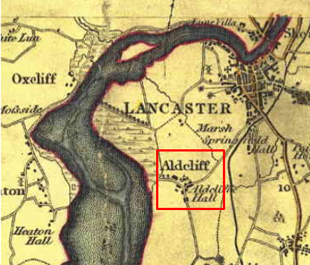
Observations |  | The application route is not shown.  The village of Aldcliffe is shown and Aldcliffe Hall labelled (although it is not clear which building it is).
Investigating Officer's Comments |  | The application route may have existed as access to Aldcliffe Hall in 1818 but it was of little significance and was therefore not included on the map.
Hennet's Map of Lancashire | 1830 | Small scale commercial map. In 1830 Henry Teesdale of London published George Hennet's Map of Lancashire surveyed in 1828-1829 at a scale of 71/2 inches to 1 mile. Hennet's finer hachuring was no more successful than Greenwood's in portraying Lancashire's hills and valleys but his mapping of the county's communications network was generally considered to be the clearest and most helpful that had yet been achieved.
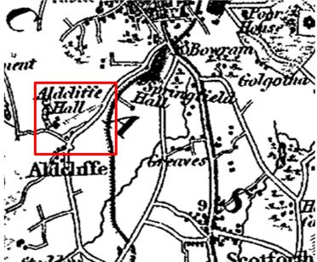
Observations |  | The application route is shown as providing direct access to Aldcliffe Hall.
Investigating Officer's Comments |  | The application route existed in 1830 and provided access to Aldcliffe Hall. It did not appear to be shown as a through route connecting to two public vehicular highways (Aldcliffe Road and Aldcliffe Hall Lane).
Canal and Railway Acts |  | Canals and railways were the vital infrastructure for a modernising economy and hence, like motorways and high speed rail links today, legislation enabled these to be built by compulsion where agreement couldn't be reached. It was important to get the details right by making provision for any public rights of way to avoid objections but not to provide expensive crossings unless they really were public rights of way. This information is also often available for proposed canals and railways which were never built.
Observations |  | The application route is not crossed by any proposed, existing or disused railway or canals.
Investigating Officer's Comments |  | No inference can be drawn with regards to the existence of public rights.
Tithe Map and Tithe Award or Apportionment | 1847 | Maps and other documents were produced under the Tithe Commutation Act of 1836 to record land capable of producing a crop and what each landowner should pay in lieu of tithes to the church. The maps are usually detailed large scale maps of a parish and while they were not produced specifically to show roads or public rights of way, the maps do show roads quite accurately and can provide useful supporting evidence (in conjunction with the written tithe award) and additional information from which the status of ways may be inferred.
Observations |  | The Tithe Map for Aldcliffe was inspected in the County Records Office but did not cover the whole of the parish and did not cover the land crossed by the application route.
Investigating Officer's Comments |  | No inference can be drawn with regards to the existence of public rights.
Inclosure Act Award and Maps |  | Inclosure Awards are legal documents made under private acts of Parliament or general acts (post 1801) for reforming medieval farming practices, and also enabled new rights of way layouts in a parish to be made. They can provide conclusive evidence of status.
Observations |  | There is no Inclosure Award for Aldcliffe or Ashton with Stodday deposited in the County Records Office.
Investigating Officer's Comments |  | No inference can be drawn with regards to the existence of public rights.
6 Inch Ordnance Survey Map | 1848 | The earliest Ordnance Survey 6 inch map for this area surveyed in 1844-45 and published in 1848.
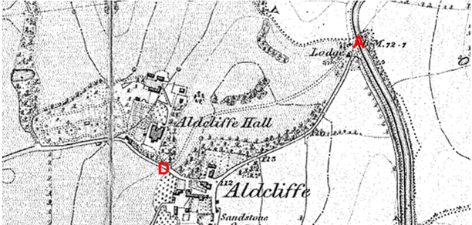
Observations |  | The full length of the application route is shown as an unbounded track. From point A the route passes a building named as Lodge and is shown to pass through a shaded area indicating parkland. The route is shown to run from Aldcliffe Road (point A) through to Aldcliffe Hall Lane (point D) and also appears to provide access to Aldcliffe Hall itself.
Investigating Officer's Comments |  | The application route existed in 1848 as a through route.
25 Inch Ordnance Survey Map | 1893 | The earliest Ordnance Survey map at a scale of 25 inch to the mile. Surveyed in 1890-91and published in 1893.
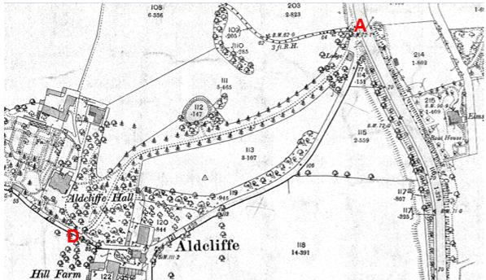
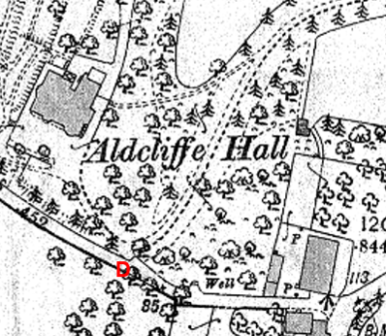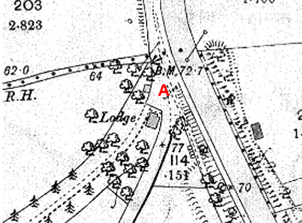
Observations |  | The full length of the application route is shown. A line is shown across the route adjacent to the lodge at point A suggesting that entry onto the route from Aldcliffe Road was gated. The route is then shown passing between an enclosed strip of land planted with trees along the same alignment as the route now claimed. Aldcliffe Hall is shown west of the application route with a track (double pecked lines) leading off from the application route directly to the Hall before reaching point D. At point D there appears to be a further track curving back round to the Hall from the application route. Access from the application route onto Aldcliffe Hall Lane at point D appears to be gated.
Investigating Officer's Comments |  | The application route existed in 1893 but appeared to be gated at point A and point D and did not appear to form part of the public vehicular highway network at that time. The fact that it is shown as a tree lined route with a gated lodge at point A and as a route providing access to Aldcliffe Hall suggests that it was constructed as an estate access road to the Hall as opposed to a public vehicular through route.
25 inch Ordnance Survey Map | 1913 | Further edition of the 25 inch map surveyed in 1890-91, revised in 1910 and published in 1913.
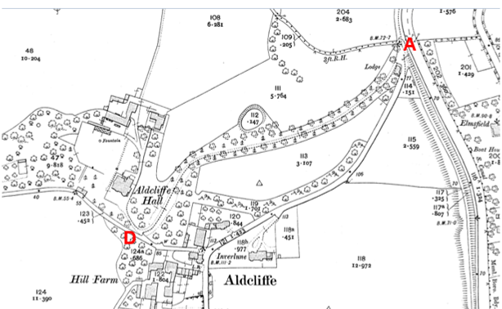
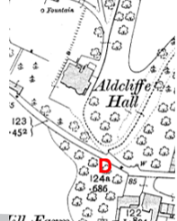
Observations |  | The application route is shown in the same way as it was shown on the earlier edition of the 25 inch map. It is gated at both ends (points A and D) and is shown as providing access to Aldcliffe Hall from a track which leaves the application route at point D.
Investigating Officer's Comments |  | The application route existed in 1913 and provided gated access to Aldcliffe Hall. It may have been possible to travel along the application route from point A to point D but the way the route is shown depicted on the map is consistent with a route whose primary purpose was access to a property (Aldcliffe Hall).
Bartholomew half inch Mapping | 1905-1940 | The publication of Bartholomew's half inch maps for England and Wales began in 1897 and continued with periodic revisions until 1975. The maps were very popular with the public and sold in their millions, due largely to their accurate road classification and the use of layer colouring to depict contours. The maps were produced primarily for the purpose of driving and cycling and the firm was in competition with the Ordnance Survey, from whose maps Bartholomew's were reduced. An unpublished Ordnance Survey report dated 1914 acknowledged that the road classification on the Ordnance Survey small scale map was inferior to Bartholomew at that time for the use of motorists.
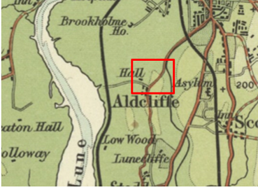
1905 edition
Observations |  | Bartholomew ½ inch maps published in 1905, 1920 and 1940 were inspected. None of the three maps show the application route.
Investigating Officer's Comments |  | The application route was not considered to be a public vehicular highway of such significance to be included on Bartholomew's Maps.
Finance Act 1910 Map | 1910 | The comprehensive survey carried out for the Finance Act 1910, later repealed, was for the purposes of land valuation not recording public rights of way but can often provide very good evidence. Making a false claim for a deduction was an offence although a deduction did not have to be claimed so although there was a financial incentive a public right of way did not have to be admitted.  Maps, valuation books and field books produced under the requirements of the 1910 Finance Act have been examined. The Act required all land in private ownership to be recorded so that it could be valued and the owner taxed on any incremental value if the land was subsequently sold. The maps show land divided into parcels on which tax was levied, and accompanying valuation books provide details of the value of each parcel of land, along with the name of the owner and tenant (where applicable).  An owner of land could claim a reduction in tax if his land was crossed by a public right of way and this can be found in the relevant valuation book. However, the exact route of the right of way was not recorded in the book or on the accompanying map. Where only one path was shown by the Ordnance Survey through the landholding, it is likely that the path shown is the one referred to, but we cannot be certain. In the case where many paths are shown, it is not possible to know which path or paths the valuation book entry refers to. It should also be noted that if no reduction was claimed this does not necessarily mean that no right of way existed.
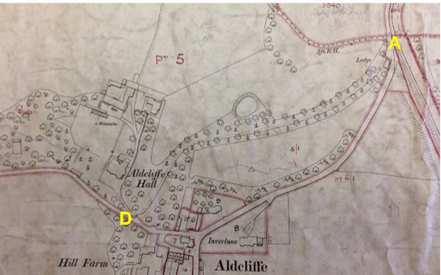
Observations |  | The whole of the application route is shown within numbered plot 5. The Valuation Book documents the land as being owned by E B Dawson and it is described as agricultural land at Aldcliffe Hall. No deductions are listed for public rights of way or user.
Investigating Officer's Comments |  | The fact that the whole of the application route was included within a numbered plot suggests that it was not considered to be a public vehicular highway at the time of the survey and no deductions are claimed for the existence of public rights of way or user suggesting that the route was either not considered to be a public right of way at the time of the survey or that the landowners chose not to claim a deduction.
25 Inch Ordnance Survey Map | 1933 | Further edition of 25 inch map (surveyed 1890-91, revised in 1931 and published in 1933.
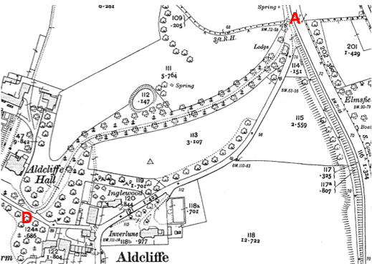
Observations |  | The application route is shown as a gated route in the same manner as it is shown on the earlier editions of the 25 inch map.
Investigating Officer's Comments |  | The application route existed but did not appear to form part of the public vehicular highway network in 1933.
Aerial Photograph | 1940s | The earliest set of aerial photographs available was taken just after the Second World War in the 1940s and can be viewed on Geographic Information System. The clarity is generally very variable.
Observations |  | There is no 1940s aerial photograph available to view in the County Records Office or online of the area crossed by the application route.
Investigating Officer's Comments |  | No inference can be drawn with regards to the existence of public rights.
6 Inch Ordnance Survey Map | 1957 | The Ordnance Survey base map for the Definitive Map, First Review, was published in 1957 at a scale of 6 inches to 1 mile (1:10,560). This map was revised before 1930 and is probably based on the same survey as the 1930s 25-inch map.
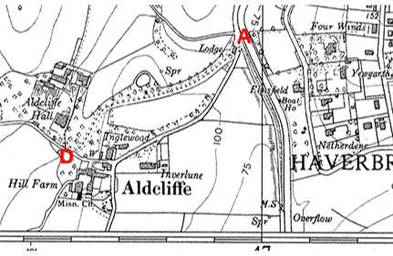
Observations |  | The application route is shown.
Investigating Officer's Comments |  | The application route existed and may have been capable of being used as a through route but did not appear to form part of the public vehicular network.
1:2500 Ordnance Survey Map | 1958 | Further edition of 25 inch map reconstituted from former county series and revised in 1956-57 and published 1958 as national grid series.
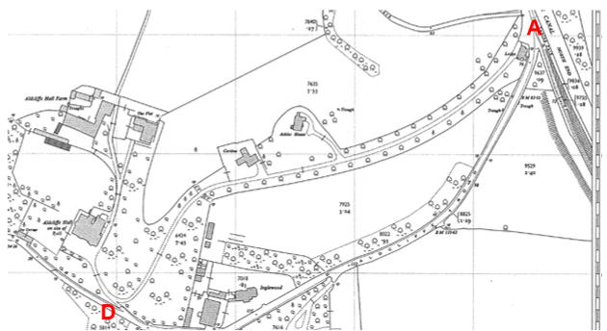
Observations |  | The application route is shown in the same way as it is shown on earlier editions of the 25 inch map and gates are still shown at point A and point D. Two new properties – named Ashlar House and Cortina are shown on the map and are directly accessed from the application route.
Investigating Officer's Comments |  | The application route existed in 1956-7 providing access to Aldcliffe Hall and two residential properties. It may have been possible to use the route as a through route connecting to public vehicular highways at point A and point D.
6 inch Ordnance Survey Map | 1968 | Further edition of the Ordnance Survey 6 inch map revised between 1956-63 and published 1968.
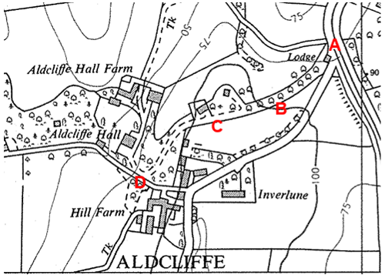
Observations |  | The application route from point A leading up to point C is shown as a strip of fenced off land planted with trees but without any track or path indicated within it.  From midway between point B and point C the application route is shown providing access to an un-named building and is then shown continuing through to point D where it is unclear whether access extended out onto Aldcliffe Hall Lane.
Investigating Officer's Comments |  | The style of this 6 inch Ordnance Survey edition differs from previous maps published. Maps pre- and post-dating this map all show the full length of the application route suggesting that it did exist in 1968 but that the eastern section from point A to midway between point B and point C was, perhaps used less frequently or was less evident on the ground than it had been in the past. The route is not shown as a route that you would expect to be able to use as a public vehicular through route.
Aerial photograph | 1960s | The black and white aerial photograph taken in the 1960s and available to view on Geographic Information System.
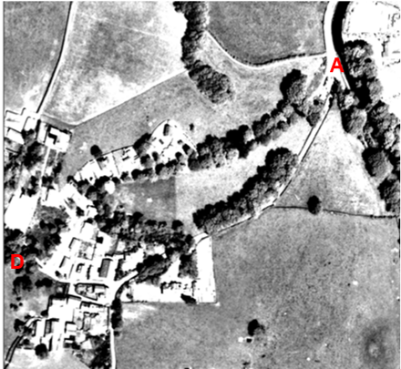
Observations |  | Tree cover means that it is not possible to see the application route in detail.
Investigating Officer's Comments |  | The application route existed in the 1960s but it is not possible to see whether it was open and accessible throughout the full length. No inference can be drawn with regards to the existence of public rights.
Ordnance Survey Pathfinder 648  Lancaster & Morecambe | 1988 | Extract from 1:25000 Ordnance Survey map revised 1988.
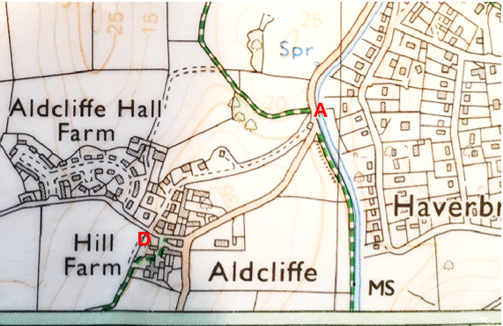
Observations |  | The application route is shown as a through route. Significant housing development has taken place since the 1960s with a number of properties being accessed directly from the application route.
Investigating Officer's Comments |  | The application route existed in 1988 and appeared to be capable of being used.
Aerial Photograph | 2000 | Aerial photograph available to view on Geographic Information System.
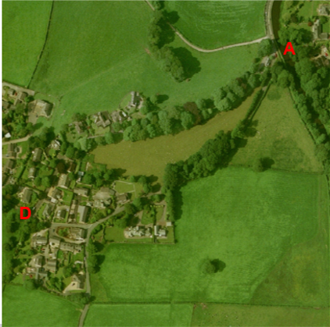
Observations |  | Tree cover means that it is not possible to see the application route in detail. The photograph shows that a number of residential properties had been built adjacent to the route between point C and point D by 2000.
Investigating Officer's Comments |  | The application route existed in the 2000 but it is not possible to see whether it was open and accessible throughout the full length. No inference can be drawn with regards to the existence of public rights.
Definitive Map Records |  | The National Parks and Access to the Countryside Act 1949 required the county council to prepare a Definitive Map and Statement of Public Rights of Way.  Records were searched in the Lancashire Records Office to find any correspondence concerning the preparation of the Definitive Map in the early 1950s.
Parish Survey Map | 1950-1952 | The initial survey of public rights of way was carried out by the parish council in those areas formerly comprising a rural district council area and by an urban district or municipal borough council in their respective areas. Following completion of the survey the maps and schedules were submitted to the county council. In the case of municipal boroughs and urban districts the map and schedule produced, was used, without alteration, as the Draft Map and Statement. In the case of parish council survey maps, the information contained therein was reproduced by the county council on maps covering the whole of a rural district council area. Survey cards, often containing considerable detail exist for most parishes but not for unparished areas.
Observations |  | The area crossed by the application route formed part of Lancaster Municipal Borough in the 1950s and no parish survey map was produced.
Draft Map |  | The Draft Maps were given a “relevant date” (1st January 1953) and notice was published that the draft map for Lancashire had been prepared. The draft map was placed on deposit for a minimum period of 4 months on 1st January 1955 for the public, including landowners, to inspect them and report any omissions or other mistakes. Hearings were held into these objections, and recommendations made to accept or reject them on the evidence presented.
Observations |  | The application route was not shown on the Draft Map and no representations were made to the county council.
Provisional Map |  | Once all representations relating to the publication of the draft map were resolved, the amended Draft Map became the Provisional Map which was published in 1960, and was available for 28 days for inspection. At this stage, only landowners, lessees and tenants could apply for amendments to the map, but the public could not. Objections by this stage had to be made to the Crown Court.
Observations |  | The application route was not shown on the Provisional Map and no representations were made to the county council.
The First Definitive Map and Statement |  | The Provisional Map, as amended, was published as the Definitive Map in 1962.
Observations |  | The application route was not shown on the First Definitive Map and no representations were made to the county council.
Revised Definitive Map of Public Rights of Way (First Review) |  | Legislation required that the Definitive Map be reviewed, and legal changes such as diversion orders, extinguishment orders and creation orders be incorporated into a Definitive Map First Review. On 25th April 1975 (except in small areas of the county) the Revised Definitive Map of Public Rights of Way (First Review) was published with a relevant date of 1st September 1966. No further reviews of the Definitive Map have been carried out. However, since the coming into operation of the Wildlife and Countryside Act 1981, the Definitive Map has been subject to a continuous review process.
Observations |  | The application route is not shown.
Investigating Officer's Comments |  | There is no indication that the application route was considered to be a public right of way by the Surveying Authority.
Highway Adoption Records including maps derived from the '1929 Handover Maps' | 1929 to present day | In 1929 the responsibility for district highways passed from district and borough councils to the county council. For the purposes of the transfer, public highway 'handover' maps were drawn up to identify all of the public highways within the county. These were based on existing Ordnance Survey maps and edited to mark those routes that were public. However, they suffered from several flaws – most particularly, if a right of way was not surfaced it was often not recorded.  A right of way marked on the map is good evidence but many public highways that existed both before and after the handover are not marked. In addition, the handover maps did not have the benefit of any sort of public consultation or scrutiny which may have picked up mistakes or omissions.  The county council is now required to maintain, under Section 31 of the Highways Act 1980, an up to date List of Streets showing which 'streets' are maintained at the public's expense. Whether a road is maintainable at public expense or not does not determine whether it is a highway or not.
Observations |  | The application route is not recorded as a publicly maintainable highway on the List of Streets.
Investigating Officer's Comments |  | No inference can be drawn with regards to the existence of public rights along the application route.
Statutory deposit and declaration made under section 31(6) Highways Act 1980 |  | The owner of land may at any time deposit with the county council a map and statement indicating what (if any) ways over the land he admits to having been dedicated as highways. A statutory declaration may then be made by that landowner or by his successors in title within ten years from the date of the deposit (or within ten years from the date on which any previous declaration was last lodged) affording protection to a landowner against a claim being made for a public right of way on the basis of future use (always provided that there is no other evidence of an intention to dedicate a public right of way).  Depositing a map, statement and declaration does not take away any rights which have already been established through past use. However, depositing the documents will immediately fix a point at which any unacknowledged rights are brought into question. The onus will then be on anyone claiming that a right of way exists to demonstrate that it has already been established. Under deemed statutory dedication the 20 year period would thus be counted back from the date of the declaration (or from any earlier act that effectively brought the status of the route into question).
Observations |  | No Highways Act Section 31(6) deposits have been lodged with the county council for the area over which the application route runs.
Investigating Officer's Comments |  | There is no intention by a landowner under this provision of non-intention to dedicate public rights of way over their land.
Google Street View Images | 2009 and 2015 | Google Street View images captured in 2009 and 2015.
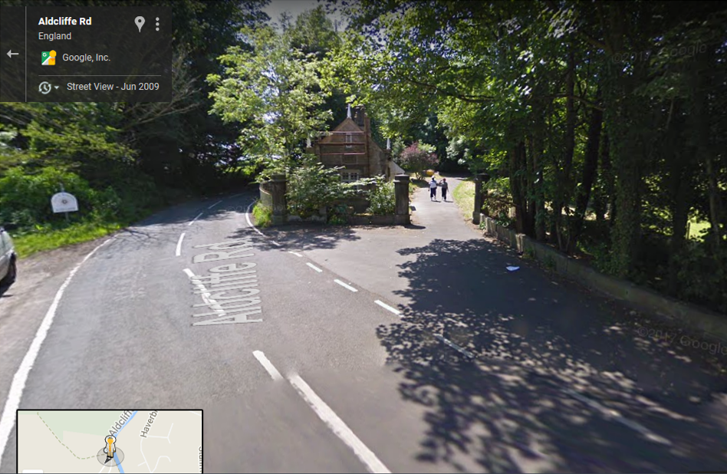
2009 – Point A

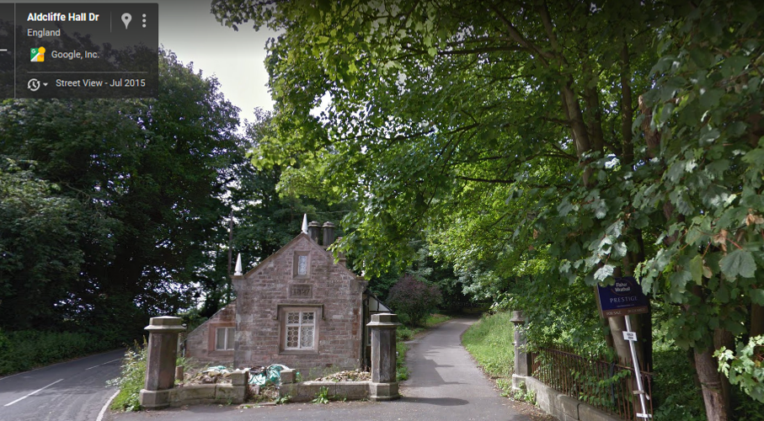
2015 – Point A
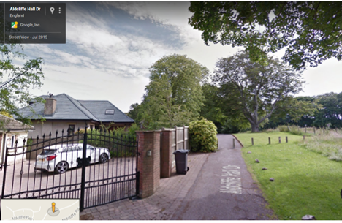
2015 – Point C

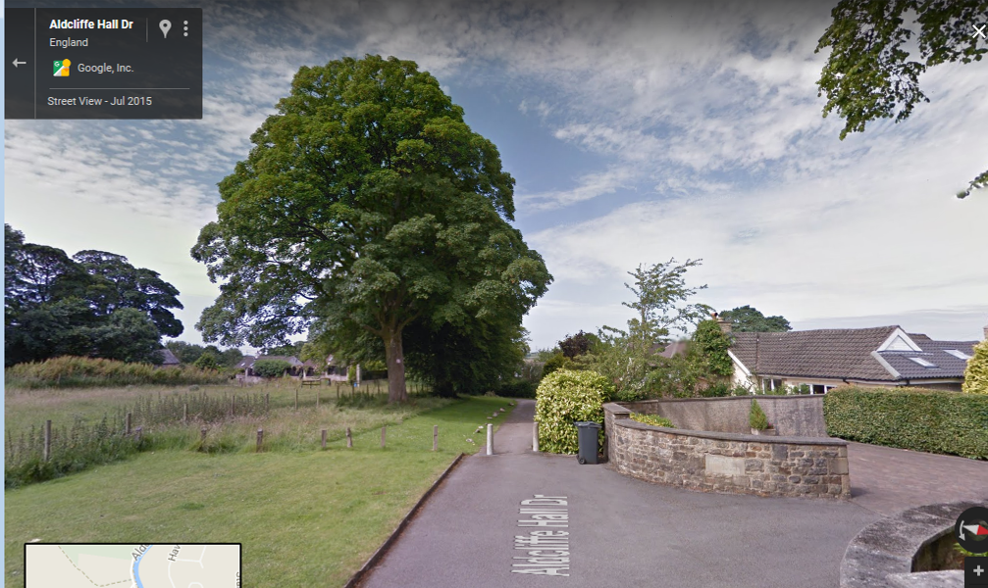
2015 – Point C

Observations |  | Google images captured in 2009 show the route open and accessible at point A with two people walking along the route and in 2015 show the route at point A open.  The 2015 images of the route at point C show bollards across the tarmacked route and extending across the mown grass strip to prevent vehicular access.
Investigating Officer's Comments |  | The photographs suggest that the route would have been capable of being used by the public in 2009 and 2015 but that access was restricted to a width of just less than 2m at point C in 2015.
Books and leaflets referred to in the application |  | The Following books and leaflets were referred to in the user evidence submitted as part of the application:  - Lancaster and Morecambe A-Z dated 2000  - Walk 4 in 'Walks around Lancaster' published in 2006 and reprinted 2015 by the Ramblers Association, Lancaster Group.  - Lancaster Ramblers Association Group leaflet published 1994 – Walk 17
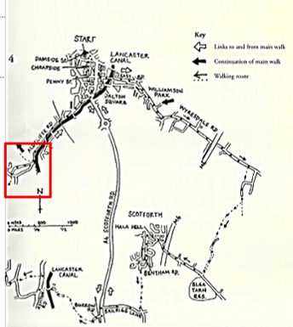
Walks Around Lancaster City – walk 4

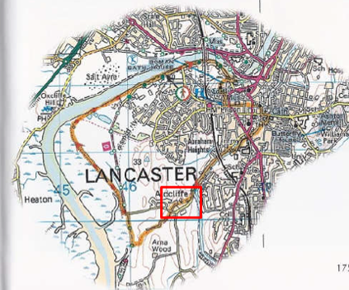
'The Lune Valley and The Howgills' – Walk 35 – Around Lancaster

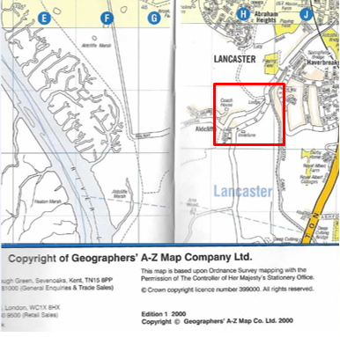
Lancaster and Morecambe A-Z
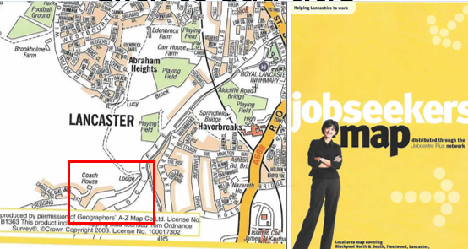
Lancaster Job Seekers Map
Observations |  | In the Lancaster Ramblers Association publication 'Walks Around Lancaster City' the application route is included as part of a circular walk described as part of 'Walk 4'. The route is described as passing some houses and continuing along a pleasant tree lined road 'to exit Old Hall Drive' by East Lodge. The hand-drawn map contained within the book shows the application route forming part of the walk. There is no indication in either the text or on the map that the route was not considered to be a public highway.  In a walk contained within a cicerone guidebook titled 'The Lune Valley and The Howgills' published in 2012 the application route is described as a lane through parkland which then drops down past houses to a junction (point D on Committee plan). There is no indication in the text or on the Ordnance Survey based map showing the walk that the route was not considered to be a public highway.  User's referred to the fact that the route was shown as an 'open road' in the Lancaster A-Z and on a Jobseekers Map of Lancaster. The route is shown on both maps with the section A-C shown to be narrower than the section C-D. No keys to the maps were provided.
Investigating Officer's Comments |  | The inclusion of the route in an A-Z is not necessarily an indication that public rights of access exist along it (even if shown as a named route) but its inclusion would support the physical existence of the route and the fact that it may have been accessible at that time.  The inclusion of the route in two walking publications – one of which was published by the local Lancaster Ramblers Association – supports the view that the route was used at least on foot buy the public and was considered to be part of the public highway network.

The affected land is not designated as access land under the Countryside and Rights of Way Act 2000 and is not registered common land.

Landownership

The entire claimed route is registered to Aldcliffe Hall Estates (Guernsey) Limited.

Summary

To summarise, the Investigating Officer was of the opinion that there was insufficient historical map and documentary evidence from which public rights could be inferred.

The map evidence supports the historical research in that the route appears to have physically existed on the same alignment since the early 1800s.

The driveway appears to have been originally constructed as access to Aldcliffe Hall, with a lodge built at the gated entrance (point A) and a tree lined driveway provided from point A to the Hall and a further gated access leading to and from the Hall (and application route) at point D.

The Finance Act documentation from the early 1900s does not show the route excluded from the numbered hereditaments and there is no deduction listed for public rights of way or user suggesting that the landowner at that time did not consider (or acknowledge) the route to be a public vehicular right of way or a public footpath or bridleway.

Following demolition of the Hall in the 1960s further houses have been constructed along either side of the application route between point C and D and this part of the route is now tarmacked with footways either side of much of it.

Vehicular access appears to be possible from point A to point C and from point D to point C but not for those wider than about 2m as a through route due to the existence of bollards at point C. The bollards are shown on google photographs taken in 2015 but no earlier map or documentary evidence was found confirming how long they had been in place or who erected them.

Reference has been made by a number of residents living adjacent to the route of a right to erect a fence across the route in deeds from the 1950s but no deeds have been made available to the county council as part of this investigation so no inference can be drawn.

The map and documentary evidence does support the user evidence submitted with regards to the fact that a route physically existed and appeared to be capable of being used throughout the period claimed but bollards at point C have restricted vehicular access along the full length since at least 2015 and most probably for longer.

Head of Service – Legal and Democratic Services Observations

Information from the Applicant

The application was supported by the following:

- 105 Evidence forms gathered from local residents of the western area of Lancaster
- 88 emails responding to the initial call for evidence
- 1 letter sent jointly by two City Councillors from Scotforth Ward
- A report prepared for the Parish Council by a working party, including the historical status of Aldcliffe Hall Drive and analysing the evidence statements
- A spreadsheet summarising the date from 105 forms used by the working party in the preparation of their report
- Map showing route of proposed Public Right of Way to be added to the Definitive Map
- Map showing location of Aldcliffe Hall Drive in relation to the City of Lancaster, the M6 motorway, the River Lune and Lancaster Canal.

User Evidence Forms

The application route use varies between the years 1954 and 2017.

Of 105 users, 67 have used the route over a continuous period of 20 years up until 2017. 1 user used the route between the years 1954 and 2011. 38 users have used the claimed route over a continuous period of 30 years up until 2017.

Usage on foot up until 2017:

- 13 users confirmed that they used the route daily since:
1960; 1977; 1978 (2); 1980 (2); 1992 (2); 1996; 1988 (2); 2001; 2007
- 35 users confirmed they used the route weekly since:
1969; 1974; 1977; 1978; 1979; 1980 (2); 1981; 1983 (3); 1985; 1987; 1988; 1989; 1990; 1993; 1994; 1995; 1996 (3); 1998; 1999; 2001 (4); 2002 (2); 2004; 2005; 2008; 2012; 2015
- 17 users confirmed they used the route monthly since:
1973; 1974; 1976; 1977 (2); 1980 (2); 1982; 1988; 1991; 1992; 1995; 1996; 2000; 2001, 2007; 2014
- 15 users confirmed they used the route every few months since:
1969; 1970 (2); 1977; 1980; 1985; 1986; 1990; 1994 (2); 1995; 2002 (3); 2007
- 2 users confirmed that they used the route on foot between 2 - 5 times per week since:
1971; 1994
- 1 user confirmed that they used the route once a year since 1990.
- 1 user confirmed that they used the route 7 times since 2014.
- 1 user confirmed that they used the route about 50 times per year not at regular intervals since 1985.
- 1 user confirmed that they used the route on foot intermittently since 1970.
- 1 user confirmed that they used the route daily from 1996 until 2009. Another confirmed using the route every few months from 1995 until 2011.

Usage on pedal cycle up until 2017:

- 3 users confirmed that they used the route daily since:
1992; 2001; 2007
- 17 users confirmed that they used the route weekly since:
- 1971; 1973; 1977 (2); 1980; 1988; 1994; 1995; 1996 (2); 1997; 2001 (2); 2005; 2008; 2009; 2015
- 19 users confirmed that they used the route monthly since:
1976; 1980 (2); 1981; 1983; 1986; 1988; 1989; 1991; 1992; 1993; 1996; 1998; 2001 (2); 2007 (2); 2011; 2012
- 1 user confirmed that they used the route weekly during the summer and every few months during the winter since 1999.
- 18 users confirmed that they used the route every few months since:
1969; 1970; 1974; 1977 (3); 1978; 1980; 1983; 1988; 1990; 1994 (2); 1995; 1996 (2); 2002; 2004
- 3 users confirmed that they used the route once a year since:
1985; 2002; 2005.

Usage by foot and bicycle:

- 1 user confirmed using the route a couple times a week by foot and bicycle from 2007 until 2015.
- 1 user confirmed using the route 7 times per year by foot and bicycle since 1990 until 2017.
- 1 user confirmed using the route monthly since 1988 until 2017 by foot and bicycle but when the weather is good they will use it weekly.
- 1 user confirmed that they used the route between 1980 – 1983 and 1996-2017 by foot and bicycle weekly or monthly depending upon the weather.
- 1 user confirmed using the route on a daily basis in the school holidays by foot and bicycle from 1954 until 2011.
- 1 user confirmed using the route by both foot and bicycle on a weekly basis between the years 1976-1992 and 1994-2017.
- 1 user confirmed using the route by both foot and bicycle on a weekly basis between the years 1972- 1982 and 1983-2017.
- 1 user confirmed using the route by both foot and bicycle every few months from 1997 – 2003 and on a weekly basis between the years 1994 - 1997 and 2003 – 2017, minus the year in-between 2006 and 2007.

No users claimed to have used the route on horseback or in a vehicle.

91 of the 105 users confirmed that the application route has always followed the same course.

The main reasons for the use of the route were for pleasure, leisure, walking, exercise, running, dog walking, going into Lancaster, visiting friends, going to school/work, cycling and for safety.

103 of the users have seen others using the claimed route at the same time as them.

100 users provided that they have seen others using the claimed route on foot.
34 users provided that they have seen people on horseback on the claimed route.
89 users provided that they have seen people cycling on the claimed route
16 users provided that they have seen people in vehicles on the claimed route.
4 users provided that they had seen wheelchairs, prams and mobility scooters using the claimed route.

65 users comment that there are bollards on the route near to Ashlar Lodge which prevent vehicle access.

98 users answered NO to ever seeing any signs or notices suggesting that the route is not a public right of way. 2 answered don’t know and 4 didn’t provide answers. 1 user provided that there was for some years, a sign attached to the gatepost at East Lodge stating that it was not a bridleway.

103 of the users answered NO to having worked for the landowner whilst using the claimed route. 2 users did not provide an answer.

When asked approximately how wide the application route is there was a wide range of answers:
Width description | No. of users | Width description | No. of users
Car width | 10 | 6 metres | 1
2 metres | 7 | Width of a lane | 1
2.5 – 3 metres | 1 | Width of a single carriageway/track | 3
2-3 metres | 3 | Width of a narrow track | 1
3 metres | 16 | 3-4 walkers wide | 1
3.5 metres | 3 | 2 cars wide | 1
3-4 metres | 6 | 7 feet | 1
2.5 – 4 metres | 1 | 8 feet | 1
4 metres | 7 | 8–15 feet | 1
3 – 4.5 metres | 1 | 10 feet | 1
4–5 metres | 1 | 12 feet | 1
5 metres | 3 | 15 feet | 1

76 users provided that the surface of the route is tarmac; whilst others described it as 'gravel-tarmac, sealed road, hard road surface, road surface, metalled, hard surface, asphalt, hard flat surface, mostly surfaced, solid concrete base, semi paved and paved'. 11 users didn’t provide an answer to the surface or didn’t know.

2 users provided that they had been given permission to use the claimed route by landowners – 1 provided that a resident of one of the houses on the claimed route granted permission. Another user owns one of the properties, 'Silver Lune' on the claimed route and provided a copy of their deed allowing them and their visitor's free passage on foot north and south along the drive.

5 people responded 'YES' to having been told that the claimed route is not public; 3 users provided that their deeds give them and any visitors access to their properties on the Drive. 1 user claimed to know from local and Ordnance Survey map knowledge and another user answered yes but didn’t provide where, when or by whom they had been told of this.

None of the users have ever been stopped or turned back when using the application route nor were they aware of anyone else being stopped or turned back.

2 users answered 'YES' to having a private right to use the application route, again these refer to deeds.

7 users answered 'YES' to having knowledge of documentary evidence of the claimed route which documents and responses included:

- A year 2000 copy of the Lancaster & Morecambe A-Z which they claim shows the route as an open road and also 'Jobseekers 2003 map' also does. Copies were not provided;
- Various historical accounts on the internet of Aldcliffe Hall, of which this route was the drive to.
- A map they had bought in 1995, showing the claimed route marked was attached to the user form.
- 'Aldcliffe Hall Drive appears in a number of walk books, though often by description rather than name. For example in Dennis and Jan Kellsall's 'Lune Valley and Howgills – A Walking Guide' (Cicerone Press Ltd. 2012), Walk 35 contains the following passage: "…continue beside Aldcliffe Road and beneath the railway. After a little less than ½ mile (800m), where road and canal part, abandon the towpath, crossing to a lane beside a lodge. It climbs through parkland to Aldcliffe, dropping past houses to a junction. A footpath signed to the River Lune leads through a gate opposite". Copies were not provided.
The drive is also a feature of the leisure mobile application Strava used by both runners and cyclists. The 'heatmaps' show the number of users of this app who have recorded their use:
http://labs.strava.com/heatmap/#15/-2.79973/54.03899/blue/run
http://labs.strava.comheatmaps/#15/-2.79973/54.03899/blue/bike '
- The route is described in the walking guide "Walks Round Lancaster City", published in 2006 by Lancaster Group of The Ramblers Association (walk 4 - page 9, map – page 8). The document was not provided.
- Another user simply provided the response 'Old maps'.

Parish Council Report

The report describes the claimed route and its features and situation and provides a short history. It describes how the local residents were asked about their use of the route through residents' newsletters and responses handled by a Parish Council working party. Evidence forms were also delivered to each house on Aldcliffe Hall Drive and some were passed on through personal contacts. Between 15/08/17 and 15/10/17 a total of 105 Evidence Statements were returned. Two forms were returned by local councillors and two Scotforth Ward City Councillors.

The report concluded that the majority of the 105 respondents used their evidence to provide that they wished to see the claimed route recorded as a 'restricted byway'. A number expressed concerns over the use of horses but none provided that they thought the route should not be a public right of way. The theme of the responses was to maintain access for the public in just the same way as it has been for the last half century. The report was received and approved at the meeting if the parish council on 12th December 2017.

Additional comments made by users are as follows:

- The application route provides a direct and safe access to The Lune footpath.
- The alternative route is the busy narrow Aldcliffe Road with blind bends, high hedges and fast traffic with no street lighting, footpaths or cycle ways. It is not suitable nor safe for non-vehicle users, particularly those with pushchairs/prams.
- They believe the route is well used by many people including people who live in the houses nearby.
- The route links the established footpaths FP41, FP49 and FP50.
- This route is the only safe, low traffic walking and cycling route between Aldcliffe and Lancaster.
- The route is a pleasant tree lined drive with lovely views.
- One user provided that whenever using the claimed route it was assumed that it was already a public right of way and they have never seen any evidence to the contrary or been challenged whilst using it.
- The route connects various other paths all of which are either traffic free or low traffic.
- One user provided that without the claimed route they would be unable to walk their children to school and another user walks their dog down the drive every day and has never been told that they cannot use the route
- The route provides an important link in an off road loop from the canal to the estuary (and onwards to Glasson Village or back into Lancaster).
- The route is a very useful connection between the Lancaster Canal footpath/cycleway and the Bay Cycleway (National Route 6).
- The route has been freely used for many years and there has never been an indication that it was private land and not a public right of way.
- A resident of Aldcliffe who claims to have co-written 'the history of Aldcliffe' states that Aldcliffe Hall Drive has been in constant daily use by local residents, Lancaster townsfolk and visitors primarily on foot and bicycle. Pedestrians and cyclists have always been welcomed. However, horse riders have always been turned back as they have been abusive and uncooperative in cleaning up their horses' dung which is a serious tripping hazard at night on the unlit road. In addition the horses' hooves have damaged the ageing tarmac and grass verges.

Information from Landowners

Bannister Bates Property Lawyers acting on behalf of the landowner, Aldcliffe Hall Estates (Guernsey) Limited object to the application. Their concerns are understandable but not strictly relevant in considering whether or not public rights already exist. These are:

- safety and well-being of the residents who access their properties from the route.
- The landowner is responsible for the proper maintenance of the route.
- The landowner only grants such legal rights of access over it as is necessary for access.
- The landowner has allowed the continued use of the roadway by the public on foot, or cycle, by consent without a formal legal right and not for general public vehicular access.
- Bollards have been in place for a substantial number of years and more recently the landowner has granted an adjoining landowner a legal right to place and maintain bollards on the route, to prevent vehicular thoroughfare.
- If the roadway is designated a restricted byway then the landowner would incur ongoing financial expense in cleaning the roadway and the removal of litter and other materials which will inevitably be caused by its use as a public byway.
- The Parish Council did not consult them prior to making the decision to submit the application, therefore had no opportunity to make representations at the parish council meeting.

The county council responded to the Bannister Bates Property Lawyers to clarify on a few points raised in their original response:

- (1) As to the consent given, the form and manner of consent or permission allegedly given and (2) Whether the owners have ever attempted to erect gates or whether gates have previously existed on the route.
- The Solicitor responded, incorrectly assuming the county council was referring to consent to place and maintain bollards and advised that consent has been given to a purchaser of one of the new units to maintain retractable bollards in place of the current concrete bollards. The landowner claims the consent forms part of the title of that unit.
- The landowner's solicitor also states that there are two large stone gateposts besides East Lodge at the entrance to Aldcliffe Hall Drive from Aldcliffe Road and therefore gates may have been there in the past, but no gates have been erected during their ownership of the land.
- The county council replied to request clarification as to what consent has been given to cyclists, pedestrians and those on or leading a horse using the route, and to specify the form and manner of the consent/permission given including to any horse riders. The response provided was that the landowner has not taken any action to prevent such use by claiming trespass against cyclists and pedestrians in the past by erection of signage or other obstructions to such use. They have, therefore, given their consent impliedly to the continued use by such parties since they purchased the land some decades ago.

Information from others

Some of owners of properties on Aldcliffe Hall Drive object to the application and have made similar comments to the landowners. They have also expressed the following concerns which whilst understandable to not have a direct bearing on whether or not public rights already exist:

- The route is a private road, not a designated public right of way and only provides vehicle access for owners of the properties down the Drive that cannot get access to their houses through Aldcliffe village.
- Horse riders, cyclists and walkers can use Aldcliffe Road to gain access to Aldcliffe Hall Lane and the footpath off Aldcliffe Hall Lane and therefore do not need to use Aldcliffe Hall Drive.
- There is also a concern that an increase in public use will result in damage to grass verges and an increase in litter, degrading the natural environment and habitats along either side of the drive.
- An increase in dog fouling.
- There is a particular concern about horse dung and damage to verges by hooves and to this end, residents have requested riders to be more considerate. This has resulted in a number of riders being aggressively offensive to the extent that the Police were called and asked to visit the stables. Their concerns are that should the claim be accepted and the route made a restricted byway then they will have no means to preventing such behaviour.
- They have concern over the speed at which cyclists travel down the drive.
- The gates at East Lodge apparently remained in place until at least 1990 when the current owners of the Lodge bought the property.
- From 1956 the use of the Drive by members of the public has been as 'tolerated trespassers', under sufferance, not because of any granted or permitted rights of way.
- Designation may encourage improper use, such as illegal parking on the Drive and verges.
- The designation may increase insurance costs for public liabilities and may result in misuse of their own private land which abuts the Drive.
- Costs of signage and other protective measures, to avoid some future claim of public rights of way over the private verges and driveways which now abut the Drive.

Assessment of the Evidence

The Law - See Annex 'A'

In Support of Making an Order(s)

- There is substantial user evidence of the route being used on foot and on pedal cycle for 20 years and longer.
- 67 people say they have used the route over a continuous period of 20 years and longer.
- 38 users have used the claimed route over a continuous period of 30 years
- None of the users were ever stopped or turned back from using the route.
- The majority of maps listed above shows that the route has existed for a long time.
- The route features in booklets and publications as a walking route, suggesting it was accessible.

Against Making an Order(s)

- Finance Act 1910 shows there are no deductions for public rights of way.
- Landowners and residents consider the route not to have public rights.
- One user claims a notice was erected to state that the route was not a bridleway.

Conclusion

In this matter it is claimed that this route has already become a public bridleway under section 31 of the Highways Act 1980. This means that a route which has been used by the public as of right and without interruption for a full period of 20 years is deemed to have been dedicated as a highway, unless there is sufficient evidence that there was no intention during that period to dedicate it.

A route can also become a bridleway inferred from all the evidence under common law. However, this is harder to prove as the current landowners and residents indicate that there is no intention to dedicate and therefore, for inferred dedication, we would need to consider whether rights had been dedicated before the current landowner and residents had any interest in this route.

There is no actual document referring to a dedication by the any previous or current landowner.

Deemed dedication under Highways Act 1980

Considering first the provisions of Section 31 Highways Act 1980. It cannot be properly determined if ever the route has been called into question before the date of the application for the route to be recorded was submitted. (20/12/2017). Therefore, the period of use to satisfy the statutory test is 20 years from 20/12/1997 to 20/12/2017. The user evidence in this matter is substantial, there is ample user evidence that the route has been used throughout this period on foot and on pedal cycle. The Committee may consider that there has been as of right use for the twenty year period without any interruption and without any sufficient overt acts demonstrating an intention not to dedicate by the owners.

In order to counter the deeming of dedication by 20 years use as of right there needs to be overt indication by the landowner. There was only one notice mentioned by one user (from a total of 105) stating that it is not a bridleway. However, it should be noted that s.31 requires that the evidence of having no intention to dedicate needs to "sufficient". To this end, the details of the alleged notice are extremely limited; there is no date available as to when it was erected; only one user out of 105 has mentioned the notice and none of the users were ever stopped from using this route. The Committee may therefore consider that this notice is not sufficient evidence of no intention to dedicate.

Inferred dedication at Common Law

The use by the public over two to three decades and owner’s acquiescence may also be circumstances from which to infer dedication at Common Law. In this regard the comments from the users who have stated to have used the route for over 20/30 years are important as it shows extensive use with no-one stopping them and there being a clear full-length link between highways.

The fact that the route is shown on a majority of maps as a through route and is also mentioned as a walking route on the Rambler's Association publications indicates the route was reputed to be available to the public at that point (earliest in 1994). Although the status of the route cannot be confirmed from the maps alone, the existence of the route connecting two vehicular highways could mean that it was used as a thoroughfare.

However, the landowners and residents have clearly expressed an intention not to dedicate and therefore we would need to refer to the time when the current landowner and residents had no interest in the route. The Committee may consider that there is insufficient evidence to infer dedication of public rights before 1997.

Taking all the evidence into account on balance, the Committee may consider that there is insufficient evidence from which a dedication of this route as a bridleway can be deemed under section 31 of the Highways Act 1980 and that the claim be accepted.

Alternative options to be considered

That the evidence is insufficient for deemed dedication of any public rights.
That the evidence shows a status other than bridleway.

Local Government (Access to Information) Act 1985

List of Background Papers

Paper | Date | Contact/Directorate/Tel
All documents on File Ref: 804-592 |  | Claire Blundell, 01772 535604, County Secretary and Solicitors Group
Reason for inclusion in Part II, if appropriate

N/A

The Ordnance Survey has produced topographic maps at different scales (historically one inch to one mile, six inches to one mile and 1:2500 scale which is approximately 25 inches to one mile). Ordnance Survey mapping began in Lancashire in the late 1830s with the 6-inch maps being published in the 1840s. The large scale 25-inch maps which were first published in the 1890s provide good evidence of the position of routes at the time of survey and of the position of buildings and other structures. They generally do not provide evidence of the legal status of routes, and carry a disclaimer that the depiction of a path or track is no evidence of the existence of a public right of way.
Aerial photographs can show the existence of paths and tracks, especially across open areas, and changes to buildings and field boundaries for example. Sometimes it is not possible to enlarge the photos and retain their clarity, and there can also be problems with trees and shadows obscuring relevant features.

